
Sec: SR.IIT_*CO-SC(MODEL-A&B) PTA-1 Date: 18-09-22
Time: 3HRS 2018_P1 Max. Marks: 180
Key Sheet

PHYSICS
1 | AC | 2 | ABD | 3 | BD | 4 | CD | 5 | ABCD
6 | AC | 7 | 2.25 | 8 | 4 | 9 | 2.5 | 10 | 6
11 | 60 | 12 | 9 | 13 | 0.6 | 14 | 3.05 | 15 | D
16 | B | 17 | A | 18 | B

CHEMISTRY
19 | ABCD | 20 | BCD | 21 | ABD | 22 | CD | 23 | BD
24 | ABD | 25 | 3 | 26 | 9 | 27 | 0 | 28 | 1
29 | 4 | 30 | 4 | 31 | 2 | 32 | 6 | 33 | B
34 | C | 35 | C | 36 | B

MATHAMATICS
37 | BC | 38 | BC | 39 | AC | 40 | AB | 41 | BC
42 | ABD | 43 | 16 | 44 | 2 | 45 | 2 | 46 | 6
47 | 4 | 48 | 6.33 | 49 | 84 | 50 | 4 | 51 | D
52 | A | 53 | C | 54 | B

SOLUTIONS
PHYSICS
1. 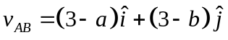
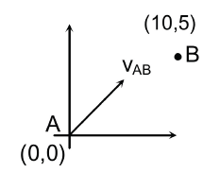
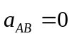
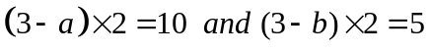
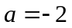 and 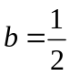

2. So, acceleration of A is always vertically downward and acceleration of B is along the incline more than 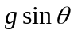. Further we can also say that there is no horizontal force on the system. So, 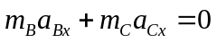.
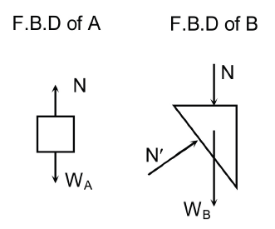
3. 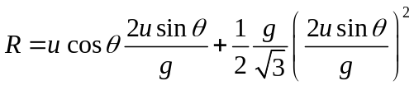
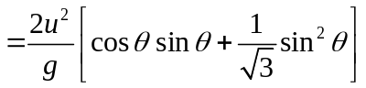
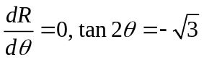
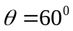
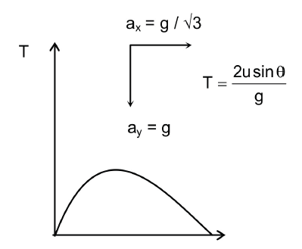
6. Let vertical velocity be v
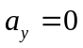
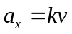
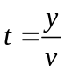
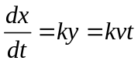
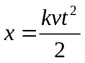
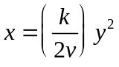
7. From the equation of trajectory 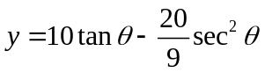
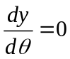 gives, 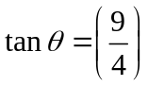
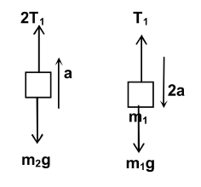
8. 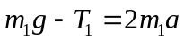
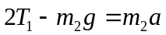
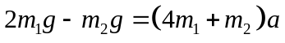
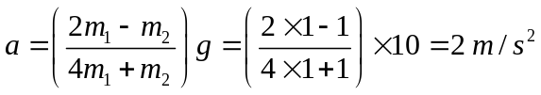
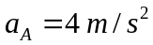

9. 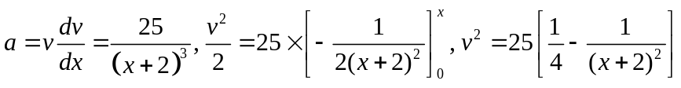
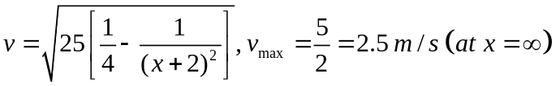
10. Let at certain moment its direction of motion makes an angle with the vertical as shown.
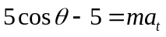
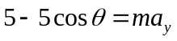
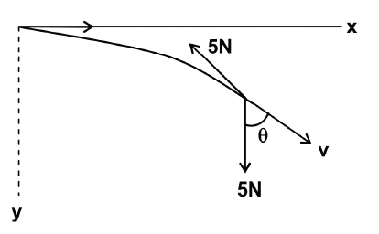
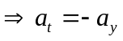
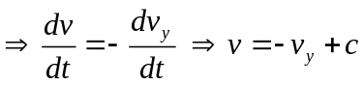
When 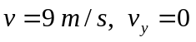
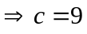
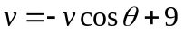
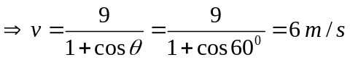

12. 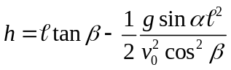
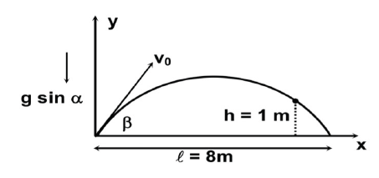
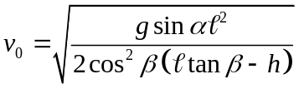
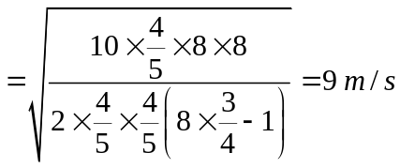
13. If they meet a height h after time T of the projection of the second.
Then, 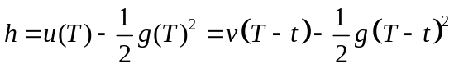 ……. (i)
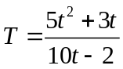
For minimum 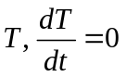
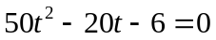
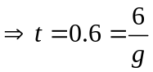
14. If 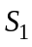 stretches by 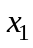, then 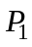 will move down by 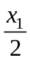,
Since tension in 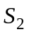 is double of that in , the second spring will stretch by 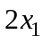
Therefore, 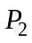 will descend by 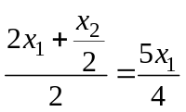
[Since moves down by ].
Now, the extension in 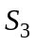 will be 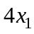
Thus, 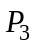 will move down by a distance
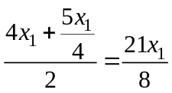
Given : 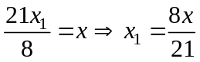
Tension in 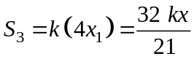
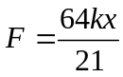

15. & 16.
Let the acceleration of B downwards be 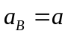
From constraint; acceleration of A and C are
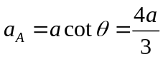 towards left
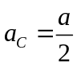 upwards
free body diagram of A, B and C are

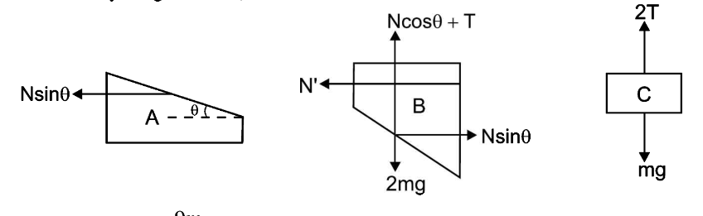

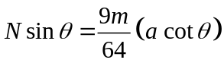 ……. (1)
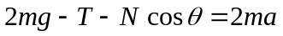 …….. (2)
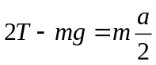 …….. (3)
Solving we get
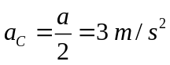 and 2T = 13 N
17.
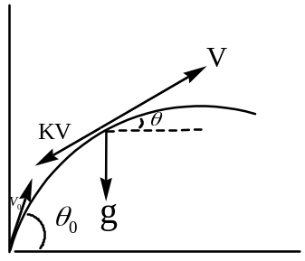
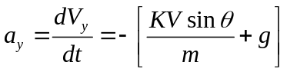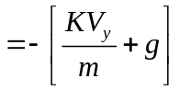
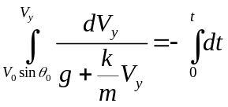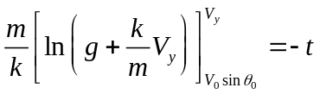
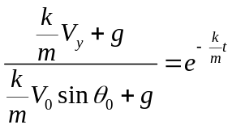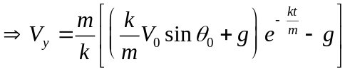
18. 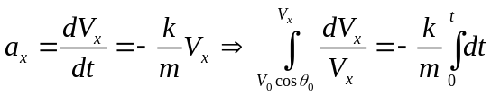 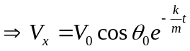
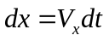
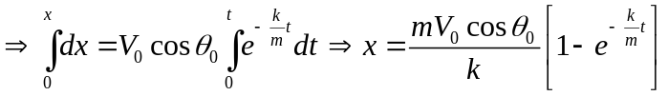
X is max at t =
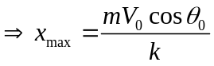

CHEISTRY
19. CONCEPTUAL
20. CONCEPTUAL
21. CONCEPTUAL
22. C) It exist in chair form (no plane of symmetry)
D) Due to Gauche conformer it has non zero dipole moment
23. CONCEPTUAL
24. CONCEPTUAL
25. CONCEPTUAL
26.
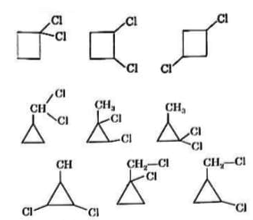
27. 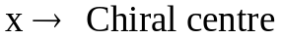
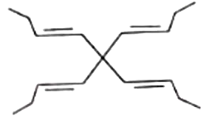
There are five stereoisomers and all of them are achiral and optically inactive.
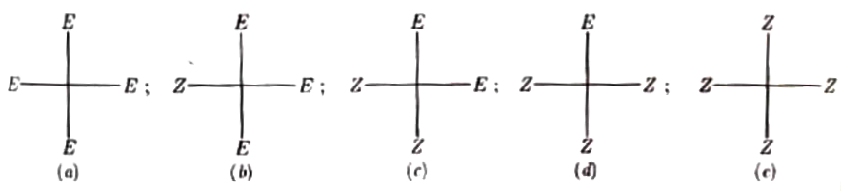
28.
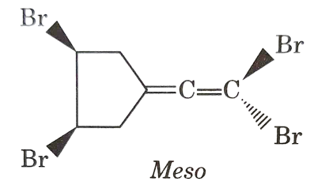
29. CONCEPTUAL
30. CONCEPTUAL
31. CONCEPTUAL
32.
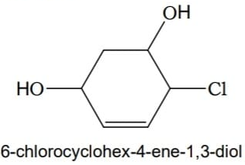
33. CONCEPTUAL
34. CONCEPTUAL
35. 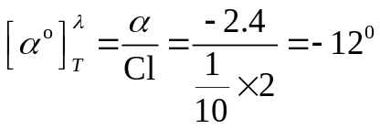
Optical purity 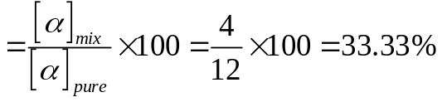
Optical purity 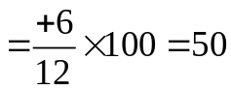
36.
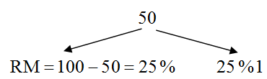
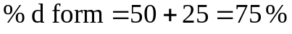

MATHS
37. 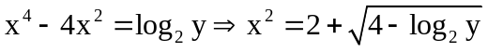 & 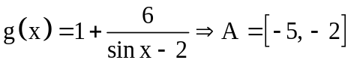
38. "O" should not exists in domain & Range
f: - odd, g- even 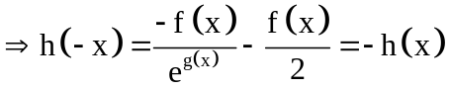
f: - odd, g- even 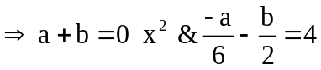
39. 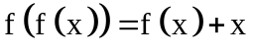 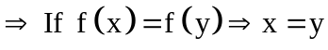
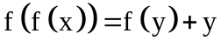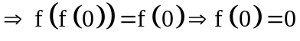
C & D :if f(x) is continuous at atleast one point.
40. 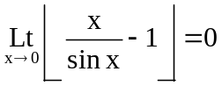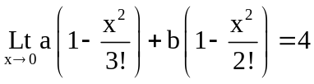
41. 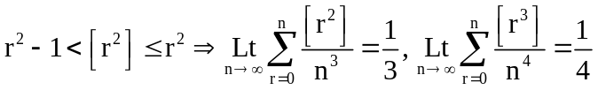
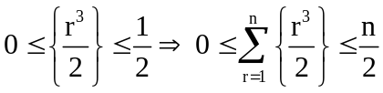
42. Period of f(x) = |sin2x| + |cos2x| is π/4
but f(x) = ln ([|sin2x| + |cos2x|])
Max. value of |sin2x| + |cos2x| = 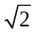
f(x) = ln ([]) = ln (1) = 0
⇒ it is periodic function but fundamental period not defined.
f(x) is many one and into function.
43.
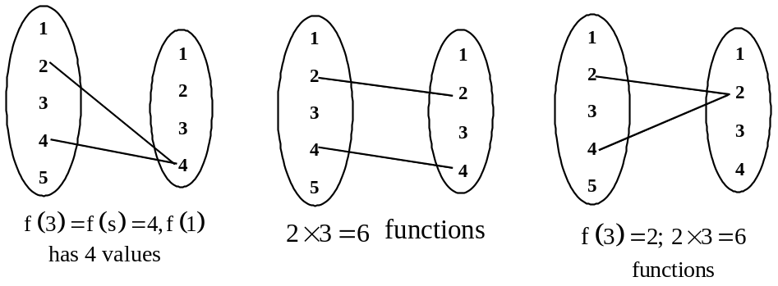
44. 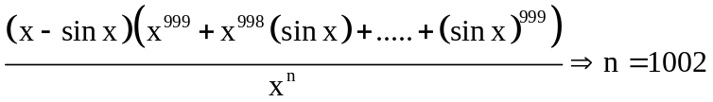
& 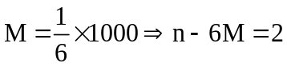
45. 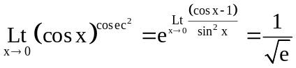
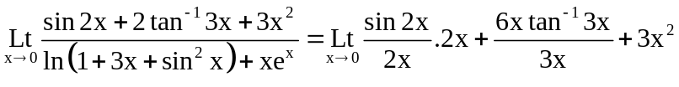
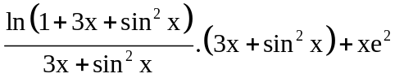
= 2
46.
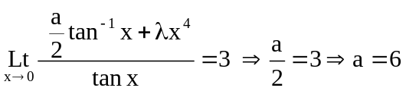
47. 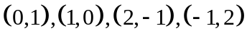 are the solutions ( By graph If (a, b) is a solution, then (b, a) is also a solution.
48. Dividie by 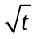 then apply limit. We get 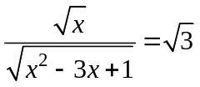 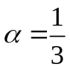 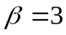.
49. 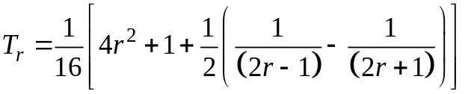
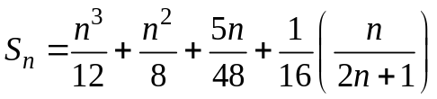
50. f(x – 2) = f(x + 6)